**Aim: Create a Simple REST Service.**

**Step1: Open netbeans .Click Services tab -> Expand Databases node. ->Right-click Java DB icon. ->Select Start Server**

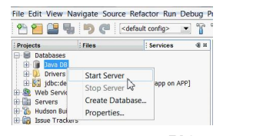

**Step2:To Create playerDB database, perform the following steps:**

**a. Right-click Java DB icon, select Create Database**

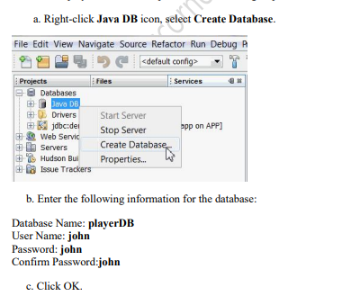

**Step3: To connect to the newly created database playerDB, Right-click jdbc:derby://localhost:1527/playerDB connection>Select Connect.**

**Step4: Click on drivers > john>tables >create tables& add column**

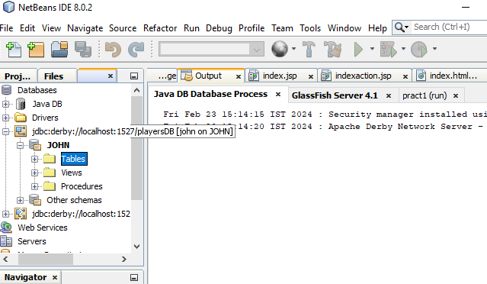

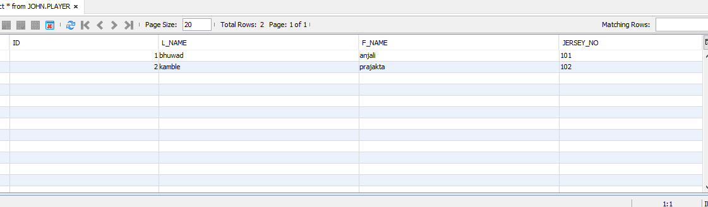

**Step5: To create new Java Web Project, select File -> New Project -> Java web -> Web Application.**

**Step6: To generate RESTful Web Services do the following: 1.Right-click the PlayerServer and choose New > Other > Web Services > RESTful Web Services from Database& Click on Database table > Data source > new data source from drop down list**

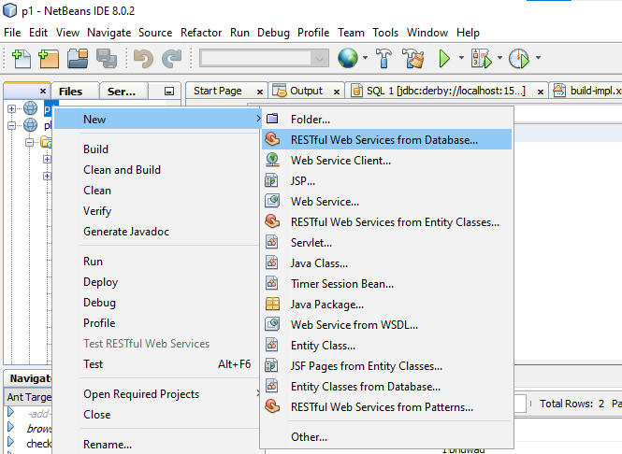

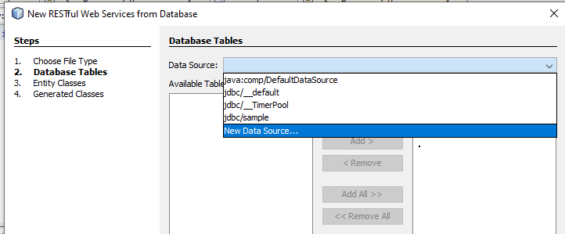

**Step7: To Create Data Source Window, enter the following information:**

**o JNDI name: jdbc/playerDB**

**o Database connection : select jdbc:derby://localhost:1527/playerDB[johnon JOHN]> ok.**

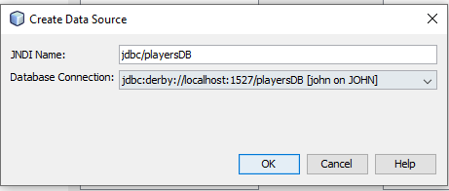

**Step8: Click Add All. The PLAYER and TEAM tables are displayed under the SelectedTables column.**

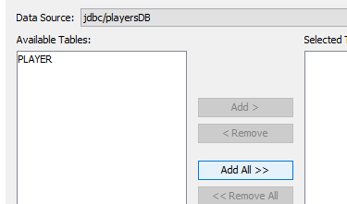

**Step9: Click on Entity Classes&Enter the package name as com.playerentity> next.**

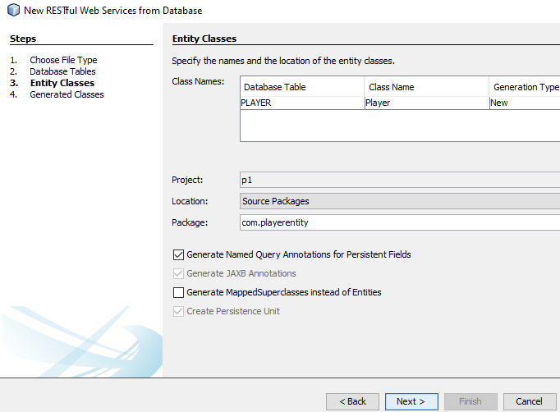

**Step10: To Generate Web Services Test client, Select PlayerServer> right click > properties.**

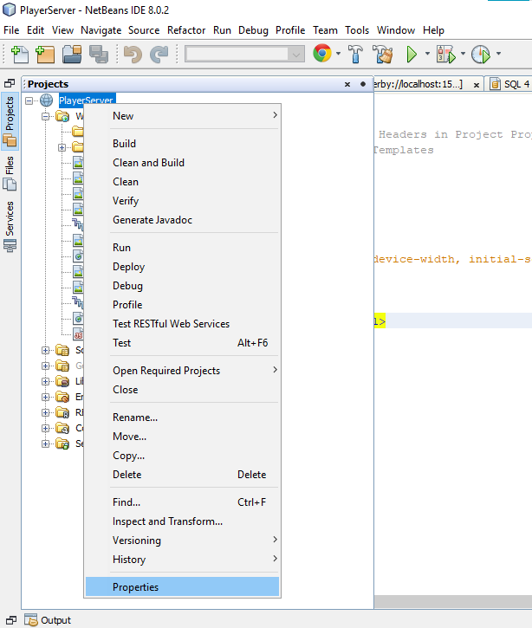

**Step11: Click on run > server & select GlassFish Server from drop down list > ok.**

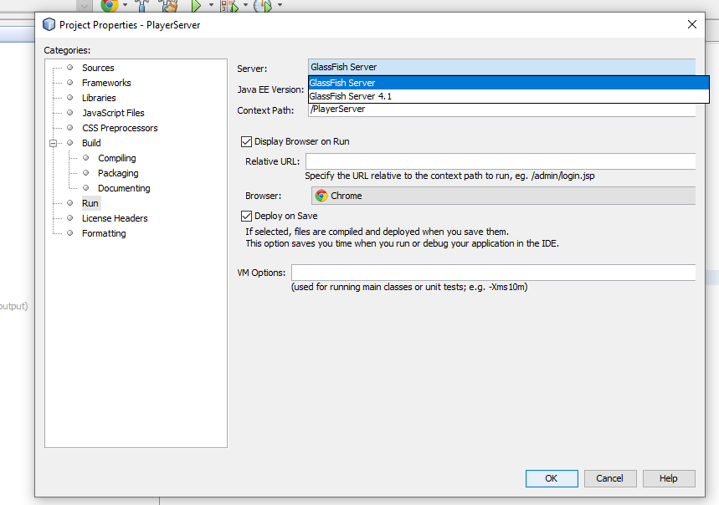

**(NOTE: - if glassfish server is not available then in services>server>rightclick then add server>click glassfish server >then browse>set the location in program files>select glassfish4.1 and then add glassfish here.)**

**Step12: Select PlayerServer project >right click & select test RESTFUL Web Services.**

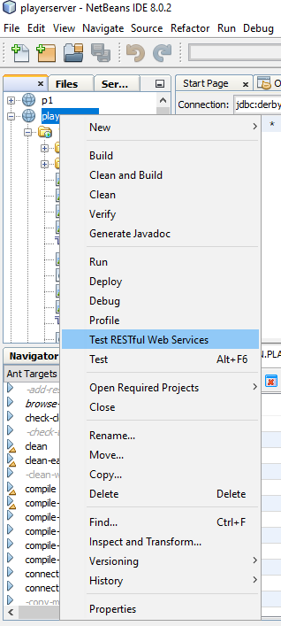

**Step13: Click on browser & select playerserver then ok.**

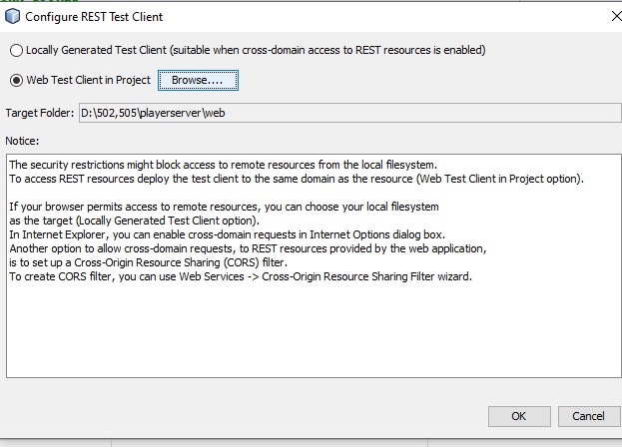

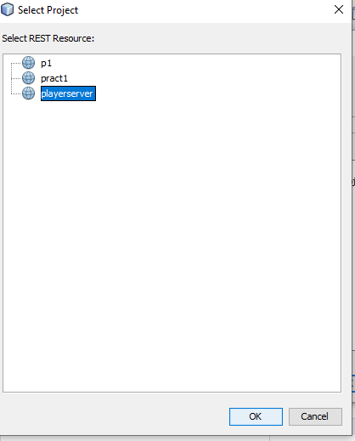

**Step14: Select Web Test in project &click Browser**

**Step15: In the select project dialog box select playerserver& click ok Then configure rest test client window is displayed & click ok**

